Stimulus articles for PACES session 12/5/2012

*Use the following articles as stimuli to write examination style questions with mark allocations and expected responses.*

1. Rust claims eats in Austal's share price

AMANDA SAUNDERS,

The West Australian

June 21, 2011, 7:09 am

|  |  |
| --- | --- |
|  | Austal shares lost as much as 6 per cent yesterday following claims that severe rust had been found aboard one of its new-generation warships built for the US Navy.  The US Navy has reportedly told Congress that "aggressive corrosion" was discovered on the USS Independence, the first aluminium-hulled littoral combat ship built by Austal. It was commissioned just 18 months ago.  Austal shares hit a low of $2.55 before recovering some ground to close down 2.9 per cent, or 8¢, at $2.63 in a broadly lower market.  Austal chief executive Andrew Bellamy rejected suggestions the reported rust could jeopardise the company's contract to build more of the LCS warships, adding that any problem could lie with lax maintenance.  "I don't believe this is going to have any impact on Austal's success as prime contractor of the littoral combat ship," Mr Bellamy said. |

"We are the world leader in the design and manufacture of this type of ship. We have built more than 230 aluminium vessels and know how to design, build and manage them to minimise corrosion."

Mr Bellamy said incidences of severe rust soon after delivery had only occurred in a handful of cases.

"In those cases the problems were primarily associated with maintenance and operation not fundamentally with the design or the build of the ship," he said.

Austal said in a statement on its website that "galvanic corrosion has not been a factor on any Austal built and fully maintained vessel".

Bloomberg reported that Navy officials were concerned about the potential for corrosion during construction of the USS Independence because of "dissimilar metals," - a reference to Austal's aluminium technology - particularly near the steel propulsion shafts. The news agency, quoting a written memo it said the US Navy had provided to a Congress committee, said the "aggressive" corrosion had been found in the propulsion system. Temporary repairs will allow the ship to operate safely until it can be dry-docked next year for repairs and the replacement of its water-jet system, the memo said.

The USS Independence and a second LCS, due to be delivered in September, were designed and built by Austal as a sub-contractor to US defence giant General Dynamics.

Revised arrangements late last year saw Austal replace the group as prime contractor, with the US Navy splitting the LCS construction program between Austal and a consortium led by US giant Lockheed Martin.

Each has been given a deal to build 10 ships at an estimated cost of $US400 million apiece. Austal is building its vessels at its US shipyard in Mobile, Alabama, where it is in the throes of doubling its workforce to 4000.

2. Redox Titration Lab Report

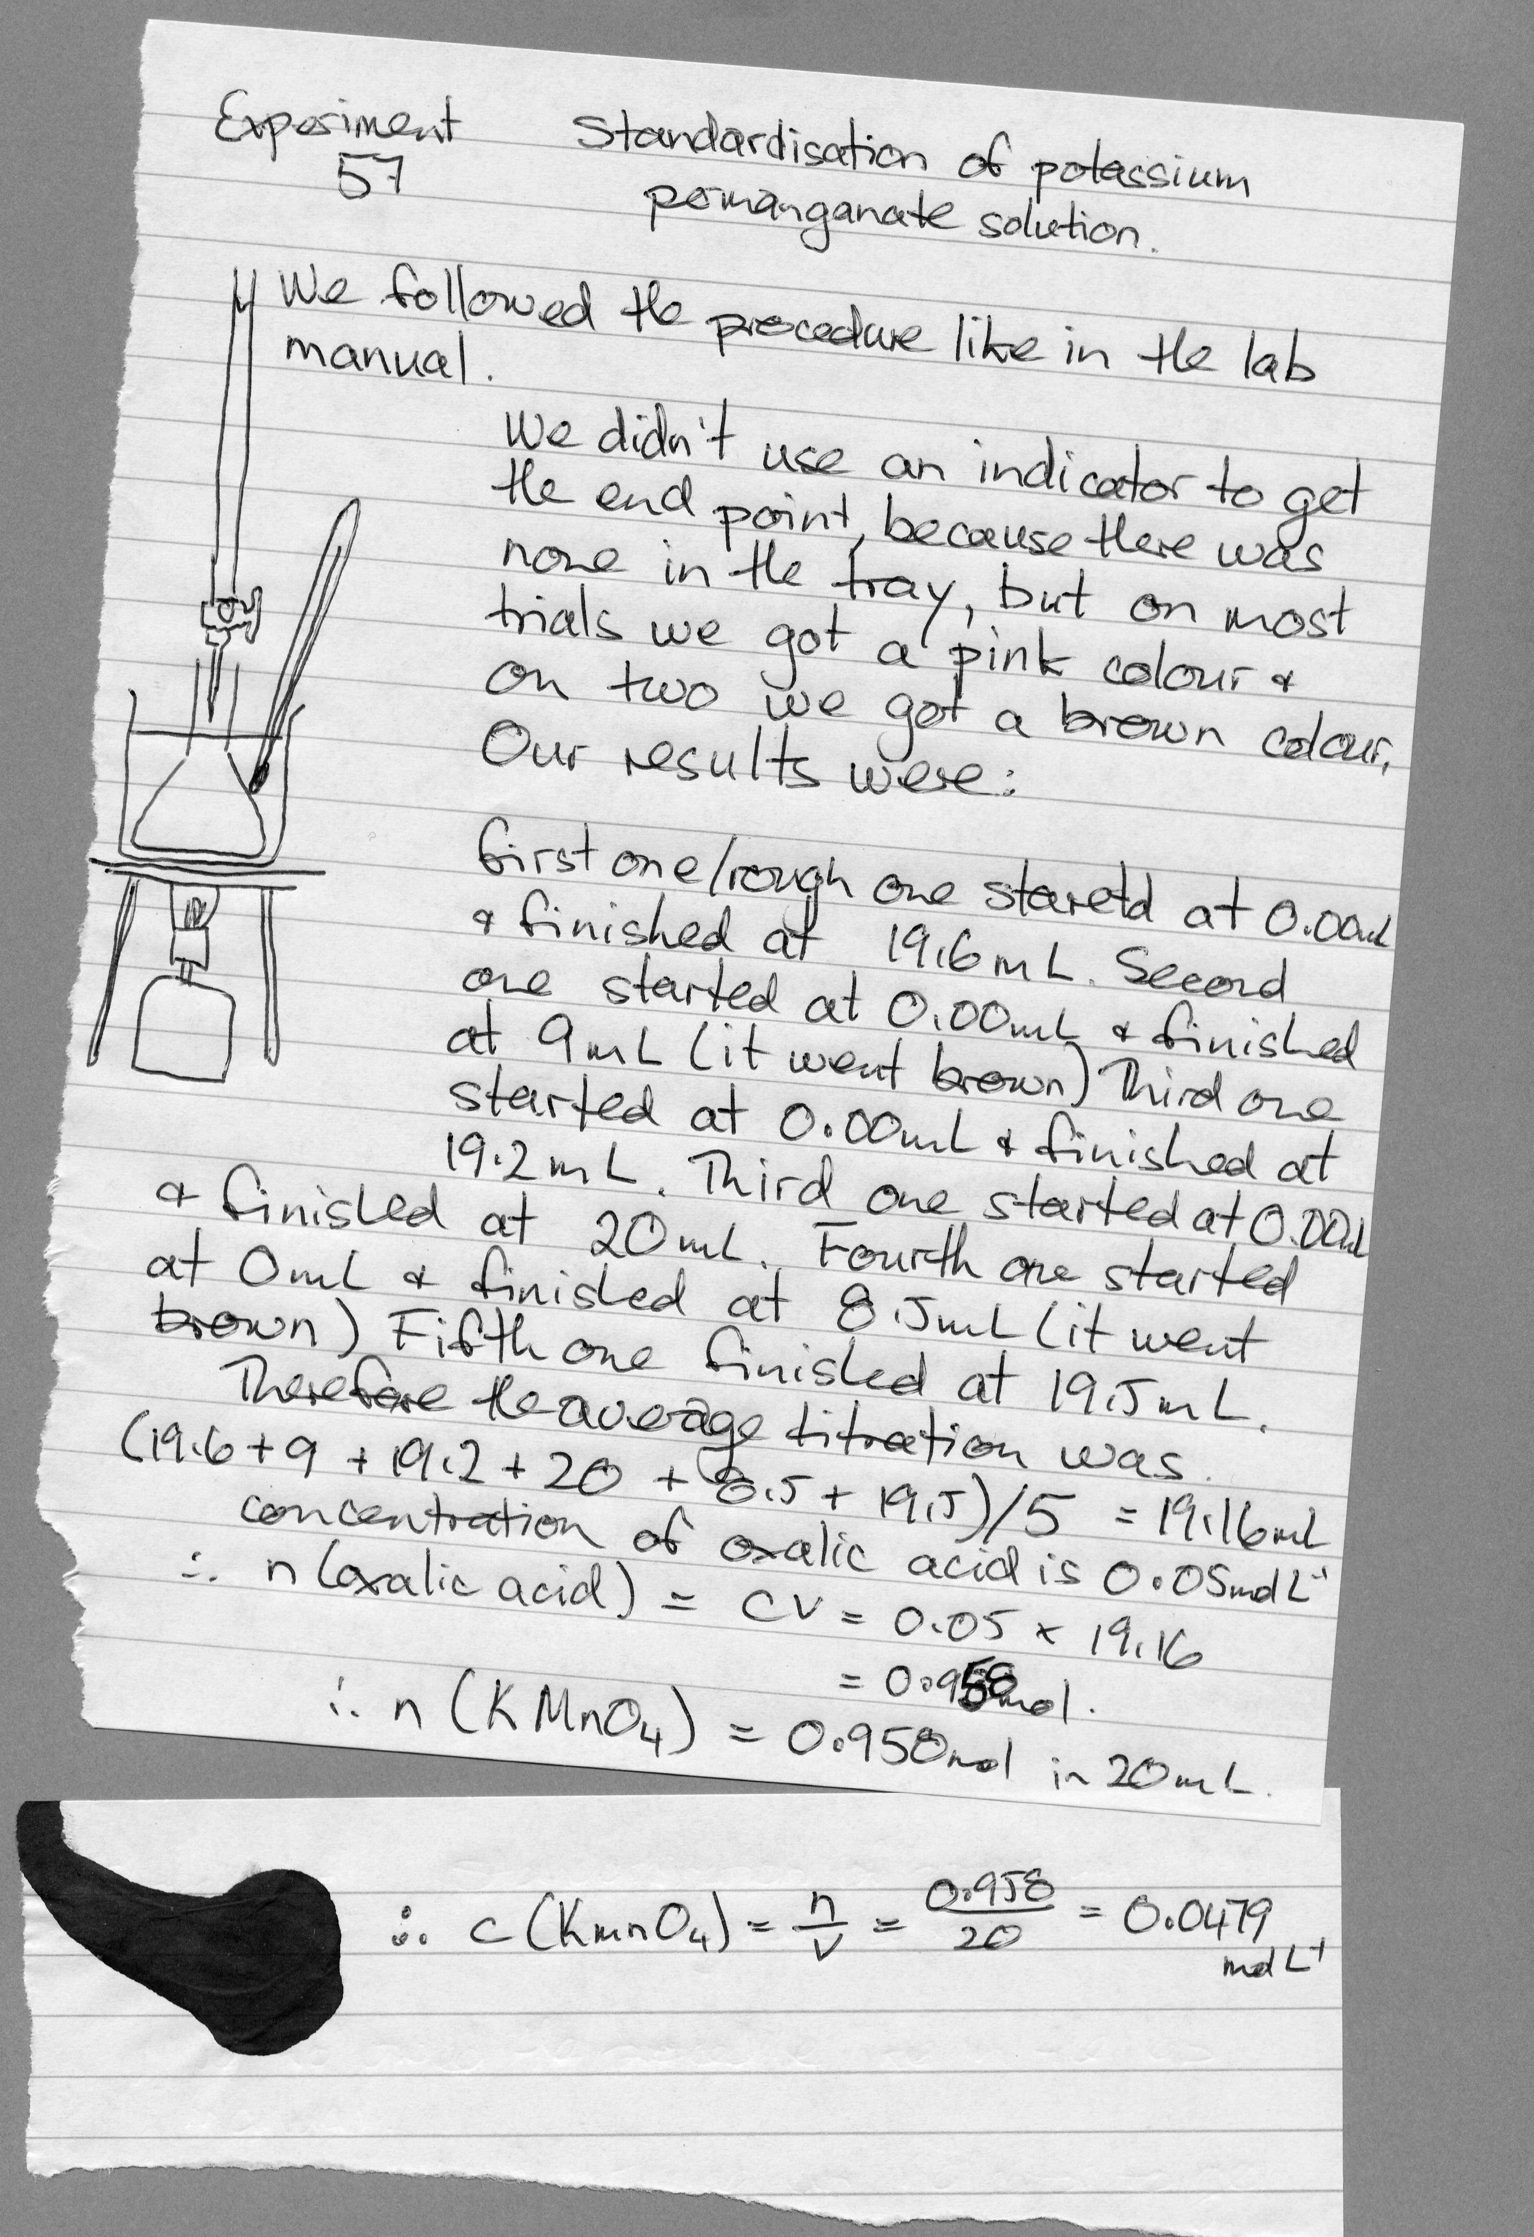

3. Room Temperature Ionic Liquids

**(**[**http://www.organic-chemistry.org/topics/ionic-liquids.shtm**](http://www.organic-chemistry.org/topics/ionic-liquids.shtm) **)**

|  |  |
| --- | --- |
| http://www.organic-chemistry.org/topics/ili.jpg  A solidified ionic liquid1) | An ionic liquid is a salt in which the ions are poorly coordinated, which results in these solvents being liquid below 100°C, or even at room temperature (room temperature ionic liquids, RTIL's). At least one ion has a delocalized charge and one component is organic, which prevents the formation of a stable crystal lattice.  The methylimidazolium and pyridinium ions have proven to be good starting points for the development of ionic liquids: |
| Properties, such as melting point, viscosity, and solubility of starting materials and other solvents, are determined by the substituents on the organic component and by the counterion. Many ionic liquids have even been developed for specific synthetic problems. For this reason, ionic liquids have been termed "designer solvents". | http://www.organic-chemistry.org/topics/ionic-1.gif |

One of the first RTILs was a mixture of [emim]Cl with AlCl3 forming a series of equilibria between [emim][AlCl4], [emim][Al2Cl7], and [emim][Al3Cl10]. This RTIL is not water stable. The discovery of water-insoluble RTILs such as [bmim][PF6] allowed the development of new work-up methods, including the separation of water-soluble by-products by simple extraction. Some transition metal catalysts that are soluble in ionic liquids may be recycled together with the ionic liquid, after extraction with water and the non-polar organic solvent used for product separation. The catalyst and ionic liquid may be recycled several times.

In addition, the following RTIL, derived from fructose (a renewable feedstock), is a promising solvent for implementing fully "[green chemistry](http://www.organic-chemistry.org/topics/green-chemistry.shtm)" methods:

[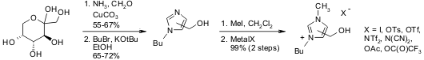](http://www.organic-chemistry.org/abstracts/literature/338.shtm)  
S. T. Handy, M. Okello, G. Dickenson, *Org. Lett.*, **2003**, *5*, 2513-2515.

This ionic liquid was proven to be suitable for Heck Reactions:

[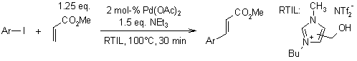](http://www.organic-chemistry.org/abstracts/literature/338.shtm)  
S. T. Handy, M. Okello, G. Dickenson, *Org. Lett.*, **2003**, *5*, 2513-2515.

The absence of volatility is one of the most important benefits of ionic liquids, offering a much lower toxicity as compared to low-boiling-point solvents. Ionic liquids can also make for safer [microwave synthesis](http://www.organic-chemistry.org/topics/microwave-synthesis.shtm) methods, because sudden pressure surges are not possible. The dipole characteristics of ionic liquids translate into rapid excitation by microwaves, and consequently faster reactions.

**Reviews on Ionic Liquids**

P. Wasserscheid, W. Keim, *Angew. Chem. Int. Ed. Engl.* **2000** , 39, 3772. [DOI](http://dx.doi.org/10.1002/1521-3773%2820001103%2939:21%3c3772::AID-ANIE3772%3e3.0.CO;2-5" \t "_blank)

4. Advanced Chem Projects – Breath Analyser

|  |  |
| --- | --- |
| Breath Analyser Test is a test used by police or hospital staff. In some countries the breath testing apparatus used by police to detect motorists who have consumed too much alcohol is called a "breathalyser". Ethanol vapour in the breath reduces orange potassium dichromate (K2Cr2O7) to green chromium ions (Cr3+).  We demonstrate a useful redox reaction in everyday life with the breath analyzer test using a simple reagent like potassium dichromate in the detection of alcohol consumed.  A chemical reaction is a process that is usually characterized by a chemical change in which the starting materials (reactants) are | http://www.buzzle.com/img/articleImages/346836-392316-30.jpg |

different from the products. Chemical reactions tend to involve the motion of electrons, leading to the formation and breaking of chemical bonds.

In a redox reaction the oxidation numbers of atoms are changed. Redox reactions may involve the transfer of electrons between chemical species.  
  
In this experiment there is a reaction between ethanol and potassium dichromate, where ethanol vapour is passed through a U-tube packed with potassium dichromate crystals, moistened with dilute sulfuric acid, to produce a visible change from the orange of chromium(VI), through brown, to the green of chromium(III). This was the reaction used in earlier forms of 'breathalyser'.  
  
The breath after drinking contains ethanol vapour, which can be oxidized by potassium dichromate (K2Cr2O7) and the orange dichromate will be reduced to green chromium ions (Cr3+).   
  
A 1 mL solution of 0.05% potassium dichromate solution and one drop of concentrated sulfuric acid is added to a small test-tube. To this, 10 mL pure ethanol (absolute alcohol) is poured into a small distilling flask containing boiling chips. The flask is slowly heated. The ethanol vapours pass through the potassium dichromate solution. The colour of the solution changes from orange to brown to green.  
  
The redox reactions for this entire process can be given as follows-   
Cr2O72-(aq) + 8H+(aq) + 3C2H5OH(l) --> 2Cr3+(aq) + 3CH3CHO(l) + H2O(l)   
K2Cr2O7 + 4H2SO4 + 3C2H5OH --> K2SO4 + Cr2(SO4)3 + 3CH3CHO + H2O   
K2Cr2O7 + 4H2SO4 + 7CH3CHO --> K2SO4 + Cr2(SO4)3 + 7CH3COOH  
The ionic equations for the reactions occurring are:  
  
(i) for oxidation of ethanol to ethanal:  
Cr2O72- + 3C2H5OH + 8H+ → 2Cr3+ + 3CH3CHO + 7H2O  
(ii) for oxidation of ethanol to ethanoic acid:  
2Cr2O72- + 3C2H5OH + 16H+ → 4Cr3+ + 3CH3COOH + 11H2O  
  
This project is enjoyable as it is simple to perform the experiment and the change of colours are visibly evident.   
  
Acknowledgments - The laboratory study of reactions was pursued diligently by Spondan Kumar and Digvijay Rawat of Class XII, R.N. Podar CBSE, Sr.Secondary High School, Santacruz(W).

By [Anjali Gharpure](http://www.buzzle.com/authors.asp?author=23228)  
Published: 1/18/2010

<http://www.buzzle.com/articles/advanced-projects-in-chemistry-the-breath-analyser.html>

5. How Does Borax Clean?

## Chemistry of Borax or Sodium Borate By [Anne Marie Helmenstine, Ph.D.](http://chemistry.about.com/bio/Anne-Marie-Helmenstine-Ph-D-7815.htm), About.com Guide

**What Is Borax?**

|  |  |
| --- | --- |
| Borax (also known as sodium borate decahydrate; sodium pyroborate; birax; sodium tetraborate decahydrate; sodium biborate) is a natural mineral compound (Na2B4O7 • 10H2O). It was discovered over 4000 years ago. Borax is usually found deep within the ground, although it has been mined near the surface in Death Valley, California since the 1800s. Although it has numerous industrial uses, in the home borax is used as a natural laundry booster, multipurpose cleaner, fungicide, preservative, insecticide, herbicide, disinfectant, desiccant, and ingredient in making 'slime'.  Borax crystals are odourless, whitish (can have various colour impurities), and alkaline. Borax is not flammable and is not reactive. It can be mixed with most other cleaning agents, including chlorine bleach. | orax is sodium tetraborate or disodium tetraborate.  This is a photo of borax crystals from California. Borax is sodium tetraborate or disodium tetraborate. *Aramgutang, wikipedia.org* |

**How Does Borax Clean?**

Borax has many chemical properties that contribute to its cleaning power. Borax and other borates clean and bleach by converting some water molecules to hydrogen peroxide (H2O2). This reaction is more favourable in hotter water. The pH of borax is about 9.5, so it produces a basic solution in water, thereby increasing the effectiveness of bleach and other cleaners. In other chemical reactions, borax acts as a buffer, maintaining a stable pH needed to maintain cleansing chemical reactions. The boron, salt, and/or oxygen of boron inhibit the metabolic processes of many organisms. This characteristic allows borax to disinfect and kill unwanted pests. Borates bonds with other particles to keep ingredients dispersed evenly in a mixture, which maximizes the surface area of active particles to enhance cleaning power.

**Risks Associated with Borax**

Borax is natural, but that does not mean it is automatically safer for you or for 'the environment' than man-made chemicals. Although plants need boron, too much of it will kill them, so borax can be used as an herbicide. Borax may also be used to kill roaches, ants, and fleas. In fact, it is also toxic to people. Signs of chronic toxic exposure include red and peeling skin, seizures, and kidney failure. The estimated lethal dose (ingested) for adults is 15-20 grams; less than 5 grams can kill a child or pet. For this reason, borax should not be used around food. More commonly, borax is associated with skin, eye, or respiratory irritation. It is also important to point out that exposure to borax may impair fertility or cause damage to an unborn child.

Now, none of these risks mean that you shouldn't use borax. If you do a bit of research, you will find risks associated with all cleaning products, natural or man-made. However, you do need to be aware of product risks so that you can use those products properly. Don't use borax around food, keep it out of reach of children and pets, and make sure you rinse borax out of clothes and off of surfaces before use.

6. Methanol Production <http://www.docbrown.info/page07/equilibria3.htm#3>.

Methanol is an important alcohol used in fuel mixtures, making methyl esters and oxidation to methanol (*formaldehyde*) to make urea-formaldehyde resin glues.

It is manufactured directly from synthesis gas (CO + H2). Historically passing steam over white-hot coke at 800-1200oC made synthesis gas. Coke is made by heating coal at high temperature and is mainly carbon. This process is still used in many parts of the world and if coal is available in a country without oil, then it will be cheaper than using hydrocarbons from oil.

C(s) + H2O(g) 🡨 🡪CO(g) + H2(g) (ΔH = +131 kJ mol-1)

The very high temperature favours the endothermic production of hydrogen and of course considerably increases the rate of reaction. Water and carbon show little reaction at lower temperatures. The reaction can be carried out at normal pressure.

Synthesis gas can also be obtained when methane is partially oxidised by reaction with the oxygen in air.

CH4(g) + 1/2O2(g) 🡪 CO(g) + 2H2(g) (ΔH = -36 kJ mol-1)

Low pressure and low temperatures are used for this reaction. This reaction can be carried out with nearly 100% conversion at atmospheric pressure at 800-1000oC using cobalt/nickel based catalysts e.g. Ni-ThO2 or Ni-SiO2. Very little water or carbon dioxide is formed if the reaction conditions are carefully controlled. Although the 'unfavourable' high temperature is needed (plus catalyst) to break the strong C-H or O=O bonds in the reactant molecules and get an effective rate of reaction, there is quite an entropy increase via the doubling of moles of gas. The reaction produces the required 1:2 ratio of CO:H2 for methanol production.

These days hydrogen is primarily made by reacting methane (natural gas) and water (steam), and the process is called steam-methane reforming.

CH4(g) + H2O(g) 🡨 🡪 3H2(g) + CO(g) (ΔH = +206 kJ mol-1)

|  |  |
| --- | --- |
| Kp = | pH23 pCO |
| ----------------- |
| pCH4 pH2O |

The reaction is carried out at 700-1000oC, over a nickel catalyst, at a pressure of 1-2 x 103 kPa (ie 10-20 atm). Using the ‘shift’ reaction (below) can further increase the yield of hydrogen.

CO(g) + H2O(g) 🡨 🡪 CO2(g) + H2(g) (ΔH = -41 kJ mol-1)

Research continues into low temperature catalysts, usually based on transition metals and their oxides e.g. Cr-Fe oxides (e.g. Fe3O4) are effective at 400-500oC, Cu-ZnO-Al2O3 at 200-400oC and CuO-ZnO at 175-325oC. The carbon dioxide can be absorbed under pressure into water or potassium carbonate solution.

CO(g) + 2H2(g) 🡨 🡪 CH3OH(g) (ΔH = -90 kJ mol-1)

|  |  |
| --- | --- |
| Kp = | pCH3OH |
| --------------- |
| pCO pH22 |

The reaction is carried out at 250oC, over a Cu-ZnO-Al2O3(alumina) catalyst at a pressure of 5-10 x 103 kPa (ie 50-100 atm). In practice a high pressure is used to give an acceptable yield but a moderately high temperature plus a catalyst.

**7.** **Buffers and Acid/Base Balance in Dairy Cows**

by Bill Tucker, Ph.D., Department of Animal and Dairy Science, Mississippi State University, Mississippi State, Mississippi

**Dairy Cows are Different**Dairy cows are unique among farm animals in the amount of acid produced in the digestive tract and found in commonly consumed feeds. Each time dairy cows approach the feed tray; they expose themselves to acid from several sources. This acid can be present in the feed when consumed, or can be generated from the feed during digestion. For example, corn silage ferments during storage, yielding a pH below 4. Therefore, consumption of silage by the cow causes rumen pH to immediately drop. Moreover, in addition to the natural acid content of silage, more acid is produced when nutrients, such as starch and cellulose in the silage, are broken down into volatile fatty acid end products.  
   How much acid does a dairy cow consume? A cow consuming 10kg of corn silage (dry matter basis) with a pH of 4, would ingest approximately 1 mg of hydrogen ion. Although 1 mg may not appear to be much acid, if it was mixed with 40 litres of water (approximate blood volume of a cow), the pH of the solution would be 4.6. This value is well below the normal blood pH of 7.4 (Rebhun, 1995) and is incompatible with life. Clearly, the natural acid content of some feeds represents a significant acid challenge to the cow.  
   Despite the importance of the acid content of feed during consumption, the release of acids from that same feed during digestion is even more substantial. Van Soest (1994) summarized data indicating that almost 1.8 kg of acetate and from 1 kg to 2.2 kg of propanoic acid are absorbed daily from the dairy cow's rumen. For perspective, to consume 1.8 kg of acetic acid, a cow would need to drink 36 litres of typical vinegar. The acid load presented to the dairy cow via the diet, through inherent acid content as well as digestion-related acid production, is large enough to cause significant health problems.

**Result of Acid Load**As acid levels derived from feed and acidic end products of digestion increase in the rumen, the pH of rumen contents decreases. Acid build-up, if severe enough, can cause several problems. As pH falls below 6.0, fibre-digesting microbes become less and less active, thereby reducing the extent of fibre digestion. In addition, sustained low pH can actually erode the rumen lining, causing it to become more permissive to the passage of bacteria from the rumen to the blood stream. This, in turn, makes the cow more susceptible to liver abscesses. Histamine production also may be increased in response to bacterial invasion, resulting in dilation of blood vessels in peripheral tissue such as the hoof. This increases the likelihood that laminitis may develop.

**Natural Defence Mechanisms   
Rumenal Defences**   
Because acid loads can negatively affect cow health, the cow possesses an intricate system of defence mechanisms to handle these challenges. This protection begins in the rumen, where numerous chemical buffers exist which can react immediately with acid as it enters or is produced in the rumen. Compounds, such as bicarbonates and phosphates, provide a large reservoir of buffering capacity, i.e., the ability to resist change in pH. These chemical buffers can absorb the hydrogen ion from acid very rapidly. During this absorption or neutralizing process, the hydrogen ion becomes bound with a harmless compound (typically, water), eliminating its negative effects on the rumen.  
   One characteristic of these chemical buffering systems is they tend to disappear after they have neutralized acid. End products produced during the neutralization often are released as gas or absorbed from the rumen. Consequently, these systems need to be replenished regularly to be effective in stabilizing rumen pH.  
   The cow relies upon salivary production of chemical buffers to replenish the buffering capacity of the rumen. Although saliva production is low during initial consumption of feed, much saliva is produced and swallowed during cud chewing. High-fibre diets that encourage cud chewing also promote substantial production of saliva and chemical buffers, thereby providing greater protection to the rumen against acid challenges. If a cow receives adequate long-stemmed fibre (e.g., hay), even when consuming a high-grain diet, she is better equipped to neutralize the significant acid production likely to occur during digestion of grain.  
**Systemic Defences**  
Although cows work hard to maintain the rumen acid-base balance as constant as possible, the acid-base status of the blood is even more critical. Normal blood pH is approximately 7.4, and variation of more than 0.2 to 0.3 pH units can make the cow severely ill. Many functions in the body, including the action of enzymes and the flow of ions into and out of the cells, are very sensitive to changes in pH. Consequently, the cow possesses a series of defence mechanisms to maintain acid-base status.  
   When acid enters the blood, a chemical buffering system similar to that in the rumen immediately reacts with the acid to neutralize it. In addition, the cow increases respiration rate and, in essence, blows acid out of the body through the lungs (in the form of carbon dioxide). If these processes fail to completely neutralize the acid, the cow's kidneys begin to excrete acid. Finally, for constant, long-term acid challenges, such as those observed for high-grain diets, the cow will begin to dissolve carbonate and phosphate buffers stored in the bones. These buffers are released into the blood, where they enhance the existing chemical buffer system. All of these systems are carefully coordinated to maximize the ability of the cow to maintain a constant acid-base status.

**Feeding to Prevent Acid Overload**Many feeding strategies exist to reduce the likelihood of dairy cows becoming acidotic. As mentioned previously, maintaining adequate fibre content and fibre length in the ration will encourage cud chewing and the release of buffers in saliva. Nutritionists recommend feeding a minimum of 2.3kg of fibre greater than 4cm in length per cow daily. Feeding smaller meals more frequently through out the day will lessen the rate of digestion-related acid release in the rumen. Including feed ingredients in the ration, such as alfalfa hay that appears to possess a natural buffering capacity, will enhance the chemical buffering system in the rumen. And finally, the chemical buffering system of the rumen may be strengthened directly through the addition of buffers to the ration.  
   Numerous compounds have been tried, evaluated, and sold as rumen buffers for dairy cows. Some, like calcium carbonate and dolomitic limestone, actually have very little buffering activity within the range of pH encountered in the rumen. Others, like magnesium oxide, are not buffers at all but rather acid neutralizers. The difference is that buffers act to maintain a constant pH, whereas acid neutralizers can only elevate the pH as they absorb acid. Both effects typically are beneficial to the dairy cow, but the processes are different.  
   Some raw, directly mined minerals, such as trona, have natural buffering capacity due to their sodium sesquicarbonate (Systematic name trisodium hydrogendicarbonate) Na3H(CO3)2 ) content, and are being sold with very little additional refinement. But the primary feed additive buffer on the market is chemically synthesized sodium bicarbonate. This buffer is most stable and active at a pH of approximately 6.1; this pH also happens to support vigorous fibre digestion in the rumen.  
   Because various types of stress can cause fluctuation in the rumen environment, and because buffers help stabilize the rumen, buffers should be added to the ration whenever dairy cows are facing unusual or stressful conditions. Heat stress, stress from high milk yield, calving stress and nutritional stress from poor-quality or inconsistent feed ingredients, as well as from high-grain diets, all pose stressful conditions. Recommendations for inclusion of buffers in the ration depend on type of buffer and the ration. A standard rule of thumb for sodium bicarbonate inclusion is 0.75% of the total diet dry matter or 15kg per tonne of grain mix. Please note that cows should not be fed buffers at any time during the dry period, due to negative effects on calcium metabolism.

**Summary**  
Any internal or external stressor can cause fluctuations in the rumen environment. The bacteria in the rumen that digest feed thrive upon both a stable environment, and an environment with a pH that is compatible with maximum microbial growth and activity. Good dairy management can control some undesirable rumen variation simply by keeping cows as comfortable and stress-free as possible. However, producing milk is hard work, and will always involve some degree of stress. Producing large quantities of milk by processing substantial amounts of grain daily causes even greater stress. Good nutrition management includes the addition of feeds to the ration to enhance a cow's ability to produce buffers, as well as the addition of buffers directly to the feed. The combination of these buffer sources enables a cow to remain healthy while digesting large quantities of feed and producing substantial amounts of milk.

8. PH, Le Chatelier's Principle

### From ChemPRIME (http://wiki.chemprime.chemeddl.org/index.php/PH,\_Le\_Chatelier%27s\_Principle)

Track: Green vs. Chemical Methods of Water Treatment in Aquariums

An aquarium can become contaminated with discoloured water due to the waste product of ammonia that is excreted from a fish. This disrupts the pH of the water.

**What is pH? Here are the facts:** The pH scale is expressed as the negative logarithm of the hydrogen ion  
concentration ranging from 0 (high [H+], acidic) to 14(high [OH-] and less H+ ions, basic). pH is short for “pondus hydrogenii” meaning “potential hydrogen.” A Danish chemist, Soren Sorensen, introduced the pH concept in 1909. The pH must be strictly regulated in an aquarium to maintain life in the tank. A good pH in the tank is between 6.8-7.2.

|  |  |
| --- | --- |
| [reen Aquarium](http://wiki.chemprime.chemeddl.org/index.php/File:Fishtank.jpg) | The pH of the aquarium water affects ammonia levels. The water can contain pure ammonia (NH3) and the ammonium ion (NH4+). Ammonia is more toxic than the ammonium ion to the fish in the tank. High pH (lower [H+]) water contains more pure ammonia, while low pH (higher [H+]) water contains the ammonium ion. Ammonia toxicity causes severe stress to fish making them more susceptible to disease and death. |

**The dissociation of ammonia equation is:**

NH4+ (aq) 🡨 🡪 NH3(aq) + H+(aq)

H2O(l) 🡨 🡪 H+(aq) + OH-(aq)

According to these equations, the formation of NH3 will depend on the pH of the water.  
If the water contains too many hydroxide ions [OH-], the system will try to rebalance itself by shifting towards producing more ammonium ions. ie a left shift.

**This shifting is described by Le Chatelier’s Principle which states**: A change in one of the variables that describe a system at equilibrium produces a shift in the position of the equilibrium that counteracts the effect of this change.

**Restoring balance:**

This system cannot be shifted to the left for too long. If it is, the [H+] will become depleted. To restore this imbalance, the system now needs to shift to the right.

***A green method of restoring acidity*** to an aquarium is by adding either vinegar, also known as acetic acid (CH3COOH), or lemon juice, which contains citric acid (C6H8O7). When these are dissolved in water, they increase the [H+] concentration. According to Le Chatelier’s principle, the reaction would proceed to the left to compensate, lowering the toxic [NH3] and increasing [NH4+]   
***Chemical Methods of Water Treatment:***

Chemical methods to rid the tank of ammonia are costly and involve ordering from various companies. One such product is called granular zeolitic medium that absorbs ammonia.

|  |  |
| --- | --- |
| [00.px](http://wiki.chemprime.chemeddl.org/index.php/File:Zeolite-200.gif) | A zeolite is a composite of over 50 different minerals in a lattice structure that contains a network of interconnected tunnels and cages. Water moves freely in and out of these pores but the zeolite framework remains rigid and acts as a molecular sieve.  Some individuals use this method because they are unaware of possible negative side effects such as the zeolite becoming covered in ‘gunk’ over time and the cost accumulation over the lifetime of a tank. |

9. The Le Châtelier principle in physiology

Many of the chemical reactions that occur in living organisms are regulated through the Le Châtelier principle.

#### Oxygen transport by the blood

Few of these are more important to warm-blooded organisms than those that relate to aerobic respiration, in which oxygen is transported to the cells where it is combined with glucose and metabolized to carbon dioxide, which then moves back to the lungs from which it is expelled.

haemoglobin + O2 oxyhaemoglobin

The partial pressure of O2 in the air is 0.2 atm, sufficient to allow these molecules to be taken up by haemoglobin (the red pigment of blood) in which it becomes loosely bound in a complex known as oxyhaemoglobin. At the ends of the capillaries, which deliver the blood to the tissues, the O2 concentration is reduced by about 50% owing to its consumption by the cells. This shifts the equilibrium to the left, releasing the oxygen so it can diffuse into the cells.

Much more detail about the mechanism by which haemoglobin transfers oxygen from the lungs to tissues, and then carries carbon dioxide and hydrogen ions back to the lungs, can be found on this U. of Virginia page. (http://web.virginia.edu/Heidi/chapter15/chp15.htm#specialfocus)

#### Maintenance of blood pH

Carbon dioxide reacts with water to form a weak acid H2CO3 that would cause the blood pH to fall to dangerous levels if it were not promptly removed as it is excreted by the cells. This is accomplished by combining it with carbonate ion through the reaction

H2CO 3 + CO32– 2 HCO3–

which is forced to the right by the high local CO2 concentration within the tissues. Once the hydrogen carbonate (bicarbonate) ions reach the lung tissues where the CO2 partial pressure is much smaller, the reaction reverses and the CO2 is expelled.

#### Carbon monoxide poisoning

Carbon monoxide, a product of incomplete combustion that is present in automotive exhaust and cigarette smoke, binds to haemoglobin 200 times more tightly than does O2. This blocks the uptake and transport of oxygen by setting up a competing equilibrium

O2-hemoglobin haemoglobin CO-haemoglobin

Air that contains as little as 0.1 percent carbon monoxide can tie up about half of the haemoglobin binding sites, reducing the amount of O2 reaching the tissues to fatal levels. Carbon monoxide poisoning is treated by administration of pure O2 which promotes the shift of the above equilibrium to the left. This can be made even more effective by placing the victim in a hyperbaric chamber in which the pressure of O2 can be made greater than 1 atm.

10. **Evaluation of galactose content in food for the benefit of galactosemics.**

We have worked to gather information in an effort to further our research into a genetic condition called Galactosaemia. Our research involves quantifying and indexing the 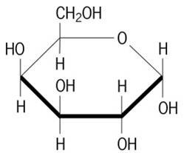galactose content of many different store brand foods including: hard and soft cheeses, tomato products, various fruits, and potato chips. Galactose found in these and other foods can be toxic to those affected by the condition if ingested in certain quantities (10 mg / 100 g of food). So far, we've noticed some interesting trends in these foods; we've found that Kraft Parmesan cheese contains very little galactose while other brands have high amounts. We are interested in whether hard cheeses (e.g. Parmesan, Romano) might be acceptable because the way they are prepared may consume most of the galactose in the milk.  We've also concluded that tomato ketchup has  less galactose as compared to other tomato products  like tomato sauces or tomato pastes. We are also indexing various brands and types of potato chips.

***Research Project***

**Evaluation of galactose content in food for the benefit of galactosemics.**

People who are galactosemics cannot metabolize galactose. A key enzyme that helps to convert galactose into glucose is defective. Instead galactose is converted to galactitol which rises to toxic levels causing damage to the brain and internal organs. Treatment is to eliminate galactose from the diet, which in a large part is the elimination of all diary products and anything containing diary products. The carbohydrate in milk is lactose, a disaccharide, made of a glucose moiety and a galactose moiety.

|  |  |
| --- | --- |
| http://chemistry.lipscomb.edu/media.asp?SID=7&UKEY=35446 | Other foods are not recommended for galactosemics if their galactose content exceeds 20 mg galactose / 100 g food. We have examined some questionable foods, because if they are consumed as condiments or only in small amounts they may be deemed acceptable, especially for older galactosemics.. For example, it is believed by some that hard cheeses should be okay because the culturing process will essentially consumed |

all of the carbohydrates in the milk as it converted to cheese. Initially we looked at some hard cheeses, tomato products, and favoured chips (many of which contain some milk). Some of our findings:

**Kraft Parmesan 3-10 mg galactose / 100g food**\*\*

**Kraft Parmesan 8 mg galactose / 100g fo**od\*\*

Kraft extra sharp cheddar 133-139 mg galactose / 100g food

Kraft mild cheddar 35 mg galactose / 100g food

DiGiorno Parmesan 11-13 mg galactose / 100g food\*\*

DiGiorno asiago 2-5 mg galactose / 100g food\*\*

DiGiorno Romano 21-24 mg galactose / 100g food\*\*

**Walmart Parmesan 216-279 mg galactose / 100g food**

Lays Potato chips 1.2 mg galactose / 100g food

Frito corn chips 0.9 mg galactose / 100g food

Dorito Nacho corn chips 518-566 mg galactose / 100g food

Dorito Cool ranch corn chips 285-461 mg galactose / 100g food

Some of the hard cheeses above (\*\*) appear to be in the acceptable range. However, questions have to be asked about the quality control of production and how it is checked. For example, does Kraft actually monitor and measure the carbohydrate level during Parmesan cheese production. The results for the Walmart store brand suggest that all Parmesan cheeses certainly are not the same.

**Do 1,3-hydride shifts occur in cyclohexyl carbocation systems?**

Dehydration of any of the methyl cyclohexanols (2-methyl, 3-methyl, or 4-methyl) lead to the same mixture of products, just in different proportions. Some of the products are not the obvious textbook answers. Dehydration of 4-methylcyclohexanol will yield some 1-methylcyclohexene which is not an obvious textbook answer. The 1-methyl-cyclohexene may arise from a tandem series of 1,2-hydride shifts or a single 1,3-hydride shift. There are reports in the literature for such 1,3-shifts. The axial hydrogens in a cyclohexyl carbocation are well placed for such a shift.

|  |  |
| --- | --- |
| http://chemistry.lipscomb.edu/media.asp?SID=7&UKEY=35447 | In an attempt is see if it is possible to observe 1,3-hydride shifts some deuterated methyl cyclohexanols were prepared. Examination of the products from the dehydration of these deuterated methyl cyclohexanols has yielded some interesting and unexpected results. When 1-d-2- methylcyclohexanol was dehydrated , the |

3-methyl and 4-methyl-cyclohexene products retained almost all of the deuterium label while the 1-methylcylo-hexene and 1-ethylcyclopetene lost over 50% of the deuterium label. The loss of the deuterium label definitely is not a textbook answer. Dehydration of 1-d-4- methyl-cyclohexanol did not show any significant lost of deuterium in the products.

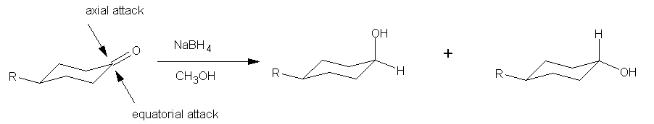

**Sodium borohydride reductions of ketones on solid supports.**

It is reported that sodium borohydride does not reduce (react with) ketones in aprotic solvents such as diethyl ether. The suggestion is that the reaction requires coordination of the carbonyl oxygen with a proton from a protic solvent such as methanol or a metal ion such a Li+ or Mg2+. It has been shown that sodium borohydride when placed onto a solid support such as silica gel (and also activated carbon) that it reacts with the ketone when the ketone is added alone with no solvent present. It is possible that water on the surface of the silica gel allows the reaction to occur by protonating the ketone or the carbonyl oxygen interacts with silica gel itself. It would be interesting to compare the reaction results of ketone reduction with sodium borohydride under these different conditions, protic solvent vs. solid support. The reactions could be examined for the possibilities of differences in the stereochemical outcomes for the reduction of cyclic and bicyclo ketones.



Sodium borohydride is also known to under go 1,4 addition, as well as 1,2-additon, with α,β-unsaturated ketones. We wish to look at the effect, if any, that a solid support system will have on 1,2 vs.1,4 additions to α,β-unsaturated ketones.

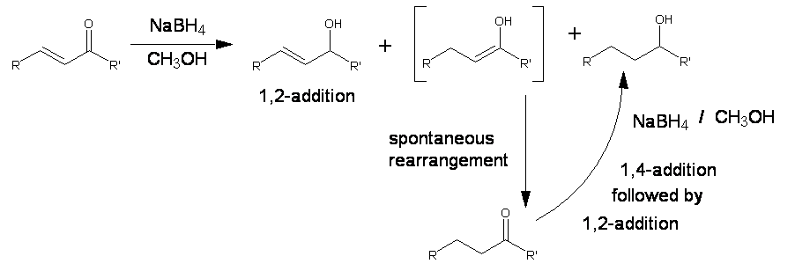

# 11. Butanoic-acid @ 3DChem.com

## Butyric acid, Butanoic-acid, Saturated Fatty Acid

|  |  |
| --- | --- |
| Butyric acid is notably found in rancid butter, Parmesan cheese, and vomit, and has an unpleasant odour and acrid taste, with a sweetish aftertaste. The glyceride of butyric acid makes up 3% to 4% of butter. When butter goes rancid, butyric acid is liberated from the glyceride by hydrolysis leading to the unpleasant odour. It is an important member of the fatty acid sub-group called short chain fatty acids. Fatty acids are a carboxylic acid with a long unbranched aliphatic tail (chain), which is either saturated or unsaturated. Fatty acids derived from natural fats and oils may be assumed to have at least 8 carbon atoms. Most of the natural fatty acids have an even number of carbon atoms, because their biosynthesis involves acetyl-CoA, a coenzyme carrying a two-carbon-atom group.  Saturated fatty acids do not contain any double bonds or other functional groups along the chain. The term "saturated" refers to hydrogen, in that all carbons (apart from the carboxylic acid [-COOH] group) contain as many hydrogens as possible. Saturated fatty acids form straight chains and, as a result, can be packed together very tightly, allowing living organisms to store chemical energy very densely. The fatty tissues of animals contain large amounts of long-chain saturated fatty acids. |  |

The human body can produce all but two of the fatty acids it needs. These two, linoleic acid (LA) and alpha-linolenic acid (LNA), are widely distributed in plant oils. In addition, fish oils contain the longer-chain omega-3 fatty acids eicosapentaenoic acid (EPA) and docosahexaenoic acid (DHA). Since they cannot be made in the body from other substrates and must be supplied in food, they are called essential fatty acids. Mammals lack the ability to introduce double bonds in fatty acids beyond carbon 9 and 10.Hence linoleic acid and linoleinic acid are essential fatty acids for humans. In the body, essential fatty acids are primarily used to produce hormone-like substances that regulate a wide range of functions, including blood pressure, blood clotting, blood lipid levels, the immune response, and the inflammation response to injury infection.

***Formal Chemical Name (IUPAC): Butyric acid***

12. Trans Fatty Acids

A ***trans*** **fatty acid** (commonly shortened to ***trans*** **fat**) is an [unsaturated](http://en.wikipedia.org/wiki/Unsaturated) [fatty acid](http://en.wikipedia.org/wiki/Fatty_acid) molecule that contains a [*trans*](http://en.wikipedia.org/wiki/Trans) [double bond](http://en.wikipedia.org/wiki/Double_bond) between [carbon](http://en.wikipedia.org/wiki/Carbon) atoms, which makes the molecule kinked. Research suggests a correlation between diets high in trans fats and diseases like [atherosclerosis](http://en.wikipedia.org/wiki/Atherosclerosis) and [coronary heart disease](http://en.wikipedia.org/wiki/Coronary_heart_disease). The [National Academy of Sciences](http://en.wikipedia.org/wiki/National_Academy_of_Sciences) recommended in 2002 that dietary intake of trans fatty acids be minimized.

|  |  |  |
| --- | --- | --- |
|  | trans configuration of hydrogen atoms | Transfats in food Though a negligible amount of trans fats are found naturally (in mostly animal foods), they are primarily formed during the manufacture of processed foods (see below for details). In unprocessed foods, most unsaturated bonds in fatty acids are in the [*cis*](http://en.wikipedia.org/wiki/Cis) configuration. |

Trans fat from partially hydrogenated vegetable oils has displaced natural solid fats and liquid oils in many areas.

Partial hydrogenation increases the shelf life and flavour stability of foods containing these fats. Partially hydrogenation also raises the melting point, producing a semi-solid material, which is much more desirable for use in baking than liquid oils. Partially hydrogenated vegetable oils are much less expensive than the fats originally favoured by bakers, such as butter or lard. Because they are not derived from animals, there are fewer objections to their use.

[Snack foods](http://en.wikipedia.org/wiki/Snack_food), fried foods, baked goods, salad dressings, and other processed foods are therefore likely to contain it, as are vegetable shortenings and margarines. Laboratory analysis alone can determine the amount.

Though some newer variants differ, most [margarines](http://en.wikipedia.org/wiki/Margarine) have much more trans fat than butter. Advocates say that the trans fats of margarine are healthier than the [saturated fats](http://en.wikipedia.org/wiki/Saturated_fat) of butter. Some say the theory that saturated fats are unhealthy is wrong anyway. See the saturated fats page for details.

## Chemistry of trans fats

Trans fatty acids are made when manufacturers add [hydrogen](http://en.wikipedia.org/wiki/Hydrogen) to [vegetable oil](http://en.wikipedia.org/wiki/Vegetable_oil) -- in a process described as partial [hydrogenation](http://en.wikipedia.org/wiki/Hydrogenation). If the hydrogenation process were allowed to go to completion, there would be no trans fatty acids left, but the resulting material would be too solid for practical use. Usually the hydrogen atoms at a [double bond](http://en.wikipedia.org/wiki/Double_bond) in a natural fatty acid are positioned on the same side of the carbon chain. However, partial hydrogenation reconfigures most of the double bonds that do not become chemically saturated, so that the hydrogen atoms end up on different sides of the chain. This type of configuration is called trans (which means "across" in Latin). The structure of a trans unsaturated chemical bond is shown in the diagram.

## Biochemistry of trans fats

Trans fat behaves like saturated fat by raising [low-density lipoprotein](http://en.wikipedia.org/wiki/Low-density_lipoprotein) (LDL or "bad [cholesterol](http://en.wikipedia.org/wiki/Cholesterol)") that increases the risk of [coronary heart disease](http://en.wikipedia.org/wiki/Coronary_heart_disease) (CHD). It also decreases levels of [HDL](http://en.wikipedia.org/wiki/High_density_lipoprotein) in the blood, this is the "good" lipoprotein that helps remove cholesterol from arteries.

Some reports have suggested that trans fats may be worse for the body than saturated fats; in fact, some studies that have incriminated saturated fat made no distinction between the two.

## Labelling of trans fats

Consumers in the [United States](http://en.wikipedia.org/wiki/United_States) can find out if a food contains trans fat by looking at the ingredient list on the food label. If the ingredient list includes the words "shortening," "partially hydrogenated vegetable oil" or "hydrogenated vegetable oil," the food contains trans fat. Because ingredients are listed in descending order of predominance, smaller amounts are present when the ingredient is close to the end of the list.

Because of public awareness of the health risks of saturated fat, food companies marketed trans fat as a healthy monounsaturated fat. Whereas actual monounsaturated oils are now thought to be healthier, trans fats (which take on many of the properties of saturated fats) are much worse.

On July 9, 2003, the United States [Food and Drug Administration](http://en.wikipedia.org/wiki/Food_and_Drug_Administration) issued a regulation requiring manufacturers to list trans fatty acids, or trans fat, on the Nutrition Facts panel of foods and some dietary supplements. This will appear below the listing of saturated fat content, which is already required to be listed.

Food manufacturers have until Jan. 1, 2006, to list trans fat on the nutrition label of items sold in the United States. The FDA estimates that by three years after that date, trans fat labelling will have prevented from 600 to 1,200 cases of coronary heart disease and 250 to 500 deaths each year. This benefit is expected to result from consumers choosing alternative foods lower in trans fatty acids as well as manufacturers reducing the amount of trans fatty acids in their products.

[Canada](http://en.wikipedia.org/wiki/Canada)'s food regulator, Health Canada, started mandatory Nutrition Facts labels in [2003](http://en.wikipedia.org/wiki/2003) (for gradual introduction over several years); from the beginning, they have required the listing of the amount of trans fats in the food described.

## Trans fats in the news

In May 2003, a U.S. non-profit corporation filed a lawsuit against the food manufacturer [Kraft Foods](http://en.wikipedia.org/wiki/Kraft_Foods) in an attempt to get Kraft to remove the trans fats from the [Oreo](http://en.wikipedia.org/wiki/Oreo) cookie. The lawsuit was withdrawn when Kraft agreed to work on ways to find a substitute for the trans fat in the Oreo.

This suit was very effective at bringing the trans fat controversy to public attention.

# 13. Zwitterions

Zwitterions (the word is derived from the German for "hybrid ion") are ions that are electrically neutral overall but contain nonadjacent regions of positive and negative charges; they are sometimes referred to as "dipolar ions." The best-known examples of zwitterions are the free amino acids found in cells.

An examination of the general structure of an amino acid reveals that there are two parts, or groups, of the molecule that can function as an acid/base pair, the –COOH and –NH 2 groups. At pH values near neutrality, a proton transfer reaction takes place that results in the –COOH becoming –COO − & the –NH 2 becoming –NH 3 + . A large favourable (stabilizing) **electrostatic interaction** now develops between these two parts of the molecule. This interaction is favourable enough to shift the [**equilibrium**](http://www.chemistryexplained.com/Di-Fa/Equilibrium.html) constant for the proton transfer reaction toward the formation of the charged species, by a factor of between 10– and 50–fold. In addition to the favourable electrostatic interaction between the charged regions, these same charged regions have very favourable electrostatic interactions with surrounding water molecules. Water molecules solvate these regions of the amino acid in a manner very similar to their solvation of cations and **anions** .

The physical properties of crystalline amino acids are consistent with their existence as zwitterions. Their melting points are relatively high, often above 200°C (392°F), and they are far more soluble in water than in **nonpolar** solvents such as ether or chloroform. Measured dipole moments for crystalline amino acids are fairly large, reflecting the significant degree of charge separation.

14.

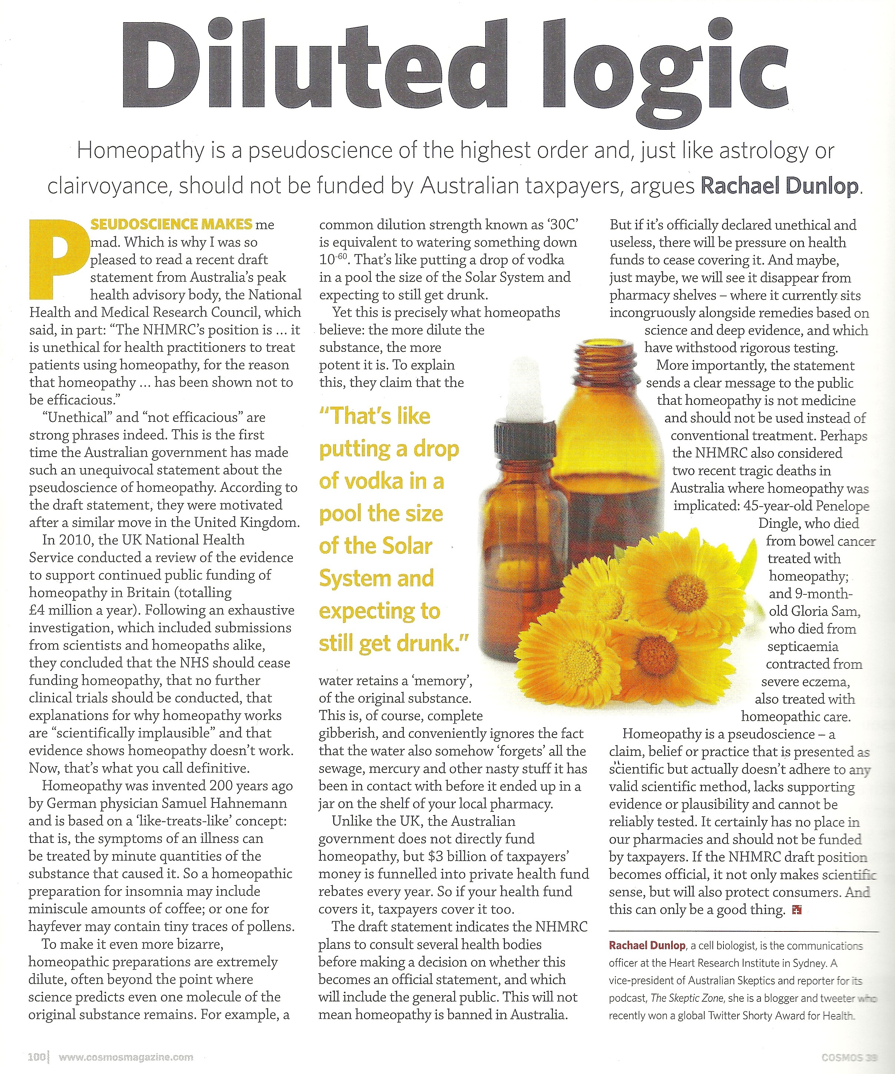

COSMOS Magazine ISSUE 39 June/July 2011